WEEK 6 FINAL DATA ANALYTICS PROJECT

E-Commerce Revenue & Profitability Intelligence

Data Analytics Internship – Final Assignment
Tools Used: Python | Pandas | NumPy | Matplotlib | Seaborn | Power BI | Git | GitHub
1. Introduction
Data analytics plays an important role in understanding business performance, identifying operational issues, and supporting data-driven decision-making. Organizations generate large amounts of transactional data through sales, customers, products, payment channels, and return activities. However, raw data cannot directly provide meaningful business insights without proper preparation and analysis.
This project focuses on analyzing an e-commerce sales dataset to understand revenue generation, profitability, customer and product performance, sales channels, regional performance, and the financial impact of product returns. The project follows an end-to-end data analytics workflow, beginning with dataset generation and data preparation, followed by exploratory data analysis, statistical analysis, visualization, and business intelligence dashboard development using Power BI.
The analysis also focuses on identifying revenue leakage caused by discounts, returns, and channel-level performance differences. The final outcome is an interactive Power BI dashboard supported by Python-based analysis and visualizations, allowing business stakeholders to understand key performance indicators and make informed decisions.
2. Problem Statement
E-commerce businesses need to continuously monitor sales, revenue, profitability, and product returns to maintain sustainable business performance. High sales do not necessarily indicate high profitability, as discounts, operational costs, payment fees, and product returns can significantly affect the final profit.
The problem addressed in this project is to analyze e-commerce transaction data and identify the major factors affecting revenue and profitability. The analysis aims to determine high- and low-performing product categories, regions, and sales channels, while also identifying the financial impact of returned orders and potential areas of revenue leakage.
The project therefore uses data analytics and business intelligence techniques to transform transactional data into meaningful business insights and actionable recommendations.
3. Project Objectives
Objectives
- To generate and analyze a realistic synthetic e-commerce sales dataset.
- To inspect the dataset for missing values, duplicate records, incorrect values, and inconsistent data.
- To clean and prepare the dataset for analysis.
- To perform exploratory data analysis using Python.
- To calculate descriptive statistics and identify important trends and patterns.
- To analyze relationships between financial variables using correlation analysis.
- To identify potential outliers and assess their business relevance.
- To create meaningful data visualizations for business interpretation.
- To develop an interactive Power BI dashboard containing KPIs, charts, and slicers.
- To identify revenue leakage associated with product returns.
- To provide data-driven business recommendations.

4. Dataset Description
- The dataset used for this project is a realistic synthetic e-commerce sales dataset created using Python. It represents transactional data from an e-commerce business and contains information related to orders, customers, products, sales channels, geographical regions, pricing, discounts, costs, returns, revenue, and profitability.
- The dataset was intentionally designed to represent realistic business conditions while also containing common data-quality issues such as missing values, duplicate records, invalid numerical values, and future-dated records. These issues were introduced to demonstrate a complete data preparation and cleaning workflow before performing analysis.
4.1 Dataset Overview
Attribute | Description
Dataset Type | Realistic Synthetic E-Commerce Sales Dataset
Original Records | 2,510
Original Columns | 26
Cleaned Records | 2,477
Cleaned Columns | 26
Duplicate Records Removed | 10
Invalid Records Removed | 20
Future-Dated Records Removed | 3
Final Missing Values | 0
Final Duplicate Records | 0
Data Period | January 2024 onward, after removal of invalid future dates
Primary Business Area | E-Commerce Sales & Profitability
4.2 Dataset Attributes
Column | Description
Order_ID | Unique identifier of an order
Order_Date | Date on which the order was placed
Customer_ID | Customer identifier
Customer_Segment | Customer classification
Region | Geographical sales region
City | Customer city
Sales_Channel | Website, Mobile App, or Marketplace
Product_ID | Product identifier
Product_Name | Name of the product
Category | Product category
Quantity | Number of units ordered
Unit_Price | Price per unit
Discount_Percent | Discount applied to the order
Gross_Sales | Sales value before discounts
Discount_Amount | Monetary value of discount
Shipping_Cost | Shipping-related cost
Payment_Fee | Payment processing fee
Cost_of_Goods | Product acquisition/manufacturing cost
Return_Flag | Indicates whether the order was returned
Return_Quantity | Number of returned units
Return_Amount | Monetary value associated with returns
Net_Revenue | Revenue after discounts and return effects
Profit | Final calculated profit
Profit_Margin | Profit as a percentage of net revenue
Payment_Method | Payment method used
Order_Status | Current order status
4.3 Dataset Coverage
The dataset covers multiple dimensions of e-commerce business performance. It includes five major product categories, four geographical regions, three sales channels, multiple customer segments, and different payment methods. This provides sufficient dimensions for analyzing revenue, profitability, returns, and operational performance.
Product Categories:
- Electronics
- Home & Kitchen
- Accessories
- Sports
- Stationery
Regions:
- West
- South
- North
- East
Sales Channels:
- Website
- Mobile App
- Marketplace
4.4 Dataset Generation Method
The dataset was generated programmatically using Python with Pandas and NumPy. A fixed random seed was used to maintain reproducibility of the dataset. Product, customer, regional, channel, pricing, discount, cost, return, and profitability attributes were generated using controlled business-oriented rules.
To make the data preparation stage realistic, several data-quality problems were deliberately introduced into the raw dataset. This allowed the project to demonstrate the complete process of detecting and correcting common problems encountered in business datasets.
5. Data Preparation and Cleaning
Before performing exploratory analysis, the raw dataset was systematically inspected and cleaned. The objective of this stage was to ensure that the dataset contained valid, consistent, and analysis-ready records.
5.1 Initial Data Quality Issues
Data Quality Issue | Records Affected | Treatment
Duplicate rows | 10 | Removed
Missing Customer Segment | 8 | Filled using mode
Missing City | 7 | Filled using region-specific mode / overall mode
Missing Payment Method | 5 | Filled using mode
Missing Discount Percentage | 5 | Filled using median
Invalid Quantity | 5 | Removed
Invalid Unit Price | 5 | Removed
Invalid Discount Percentage | 5 | Removed
Future-dated orders | 3 | Removed
5.2 Data Cleaning Steps
1. Date Conversion
The Order_Date column was converted into a proper datetime format to enable time-based analysis.
2. Duplicate Removal
Duplicate transaction records were identified and removed to prevent double counting of sales and profitability.
3. Invalid Numerical Values
Records containing non-positive quantities, negative unit prices, or discount percentages outside the valid 0–100% range were removed.
4. Future-Dated Records
Orders dated beyond the valid analysis period were identified and removed because they represented unrealistic future transactions.
5. Missing Values
Missing categorical values such as Customer Segment and Payment Method were filled using the mode. Missing City values were handled using region-based mode imputation, while missing Discount Percentage values were replaced using the median.
6. Profit Margin Validation
The existing Profit Margin field was recalculated using Profit divided by Net Revenue multiplied by 100. For returned orders with effectively zero net revenue, the profit margin was treated as undefined rather than assigning an unrealistic percentage.
5.3 Dataset Transformation Summary
Metric | Before Cleaning | After Cleaning
Rows | 2,510 | 2,477
Columns | 26 | 26
Duplicate Rows | 10 | 0
Missing Values | Present | 0
Invalid Numerical Values | Present | 0
Future-Dated Records | 3 | 0
Data Quality Status | Requires Cleaning | Passed Quality Checks
After cleaning, the final dataset contained 2,477 records and 26 columns, with no remaining duplicate records or missing values. Financial consistency checks for discount amount, net revenue, and profit calculations also passed successfully.
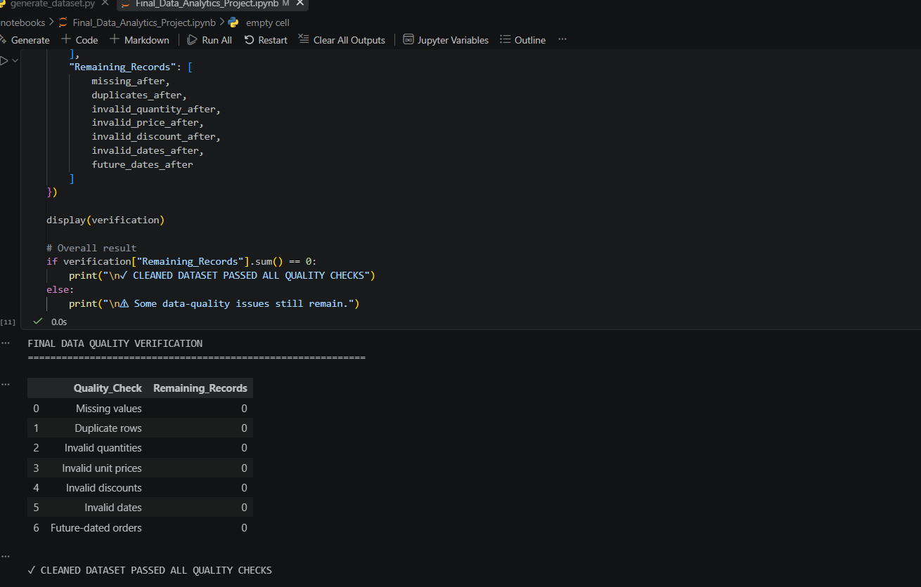
6. Exploratory Data Analysis
Exploratory Data Analysis (EDA) was performed on the cleaned dataset to understand its structure, distribution, trends, relationships, and business performance. Descriptive statistics were calculated for numerical variables, while categorical variables were analyzed to understand the distribution of orders across different categories, regions, and sales channels.
The analysis also examined monthly revenue trends, product category performance, regional profitability, sales channel performance, return behavior, correlations between financial variables, and potential outliers.
6.2 Descriptive Statistics
Descriptive statistical analysis was performed on important numerical variables such as Quantity, Unit Price, Gross Sales, Discount Amount, Net Revenue, Cost of Goods, Return Amount, and Profit. Measures such as mean, median, minimum, maximum, and standard deviation were examined to understand the distribution of the data.
Metric | Value
Total Orders | 2,477
Unique Customers | 592
Gross Sales | ₹10,535,779.37
Total Discounts | ₹797,734.45
Net Revenue | ₹9,214,991.26
Total Profit | ₹2,615,976.06
Average Order Value | ₹3,720.22
Average Profit per Order | ₹1,056.11
Returned Orders | 176
Return Rate | 7.11%
The cleaned dataset contains 2,477 orders from 592 unique customers. The business generated approximately ₹92.15 lakh in net revenue and ₹26.16 lakh in total profit. The average order value was ₹3,720.22, while 176 orders were identified as returned, resulting in an overall return rate of 7.11%.
6.3 Monthly Revenue Analysis
Monthly revenue and profitability were analyzed to identify changes in business performance over time. The analysis showed noticeable month-to-month fluctuations rather than a consistently increasing or decreasing trend.
August 2024 recorded the highest monthly net revenue at approximately ₹5.14 lakh and the highest monthly profit at approximately ₹1.45 lakh. November 2024 recorded the lowest monthly net revenue at approximately ₹2.49 lakh, with profit of approximately ₹0.58 lakh.
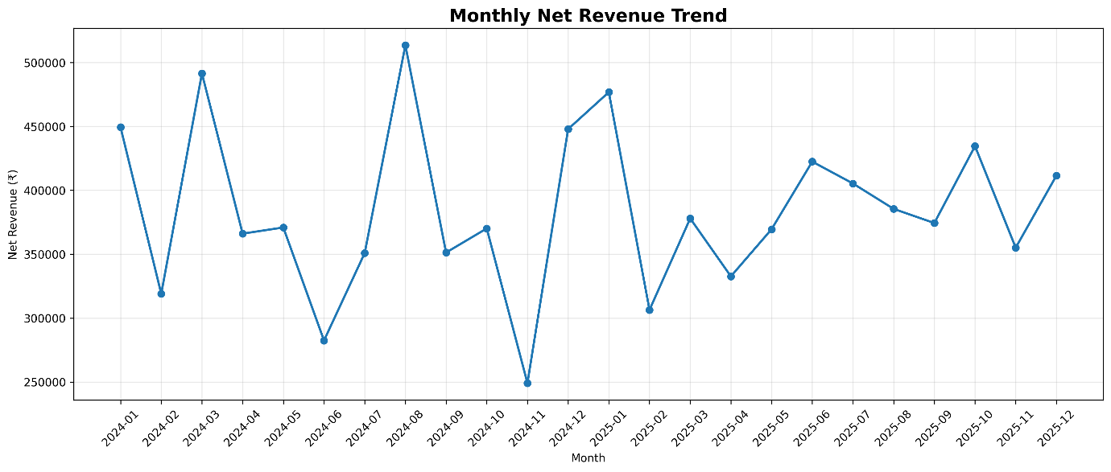
Figure 2: Monthly Net Revenue Trend
Finding: Revenue performance varies across months, indicating that business performance is influenced by changing order volumes and transaction characteristics rather than following a uniform trend.
6.4 Product Category Analysis
Product categories were compared using net revenue, profit, order volume, profit margin, and return rate. Electronics generated the highest net revenue and profit, while Stationery generated the highest profit margin.
Category | Net Revenue | Profit | Profit Margin | Return Rate
Electronics | ₹27.17 L | ₹7.27 L | 26.77% | 8.50%
Home & Kitchen | ₹27.04 L | ₹7.12 L | 26.34% | 8.91%
Accessories | ₹15.72 L | ₹5.07 L | 32.26% | 5.16%
Sports | ₹15.44 L | ₹4.11 L | 26.62% | 8.59%
Stationery | ₹6.78 L | ₹2.58 L | 38.09% | 4.25%
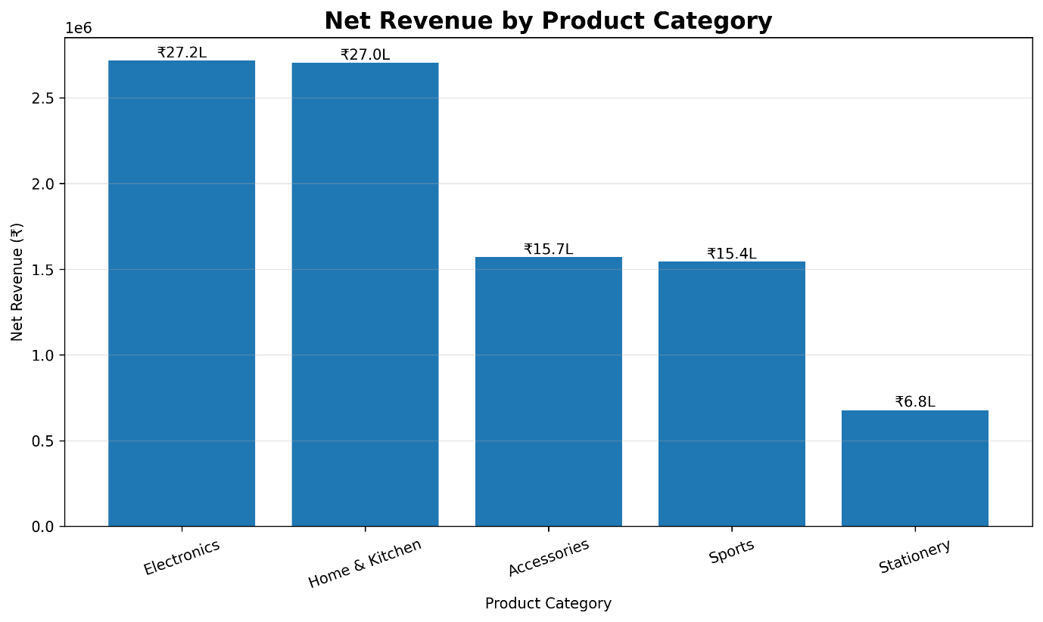
Figure 3: Net Revenue by Product Category
Finding: Electronics and Home & Kitchen are the strongest categories in terms of revenue generation. Stationery has the highest profit margin and lowest return rate, suggesting relatively efficient and stable performance despite its lower overall revenue contribution.
6.5 Regional Analysis
Regional performance was analyzed to identify geographical differences in revenue, profitability, and returns. The West region was the strongest contributor to both revenue and profit, while North showed the highest return rate.
Region | Net Revenue | Profit | Profit Margin | Return Rate
West | ₹31.58 L | ₹8.92 L | 28.26% | 6.91%
South | ₹22.93 L | ₹6.68 L | 29.14% | 6.34%
North | ₹21.75 L | ₹5.89 L | 27.07% | 8.01%
East | ₹15.89 L | ₹4.67 L | 29.36% | 7.27%
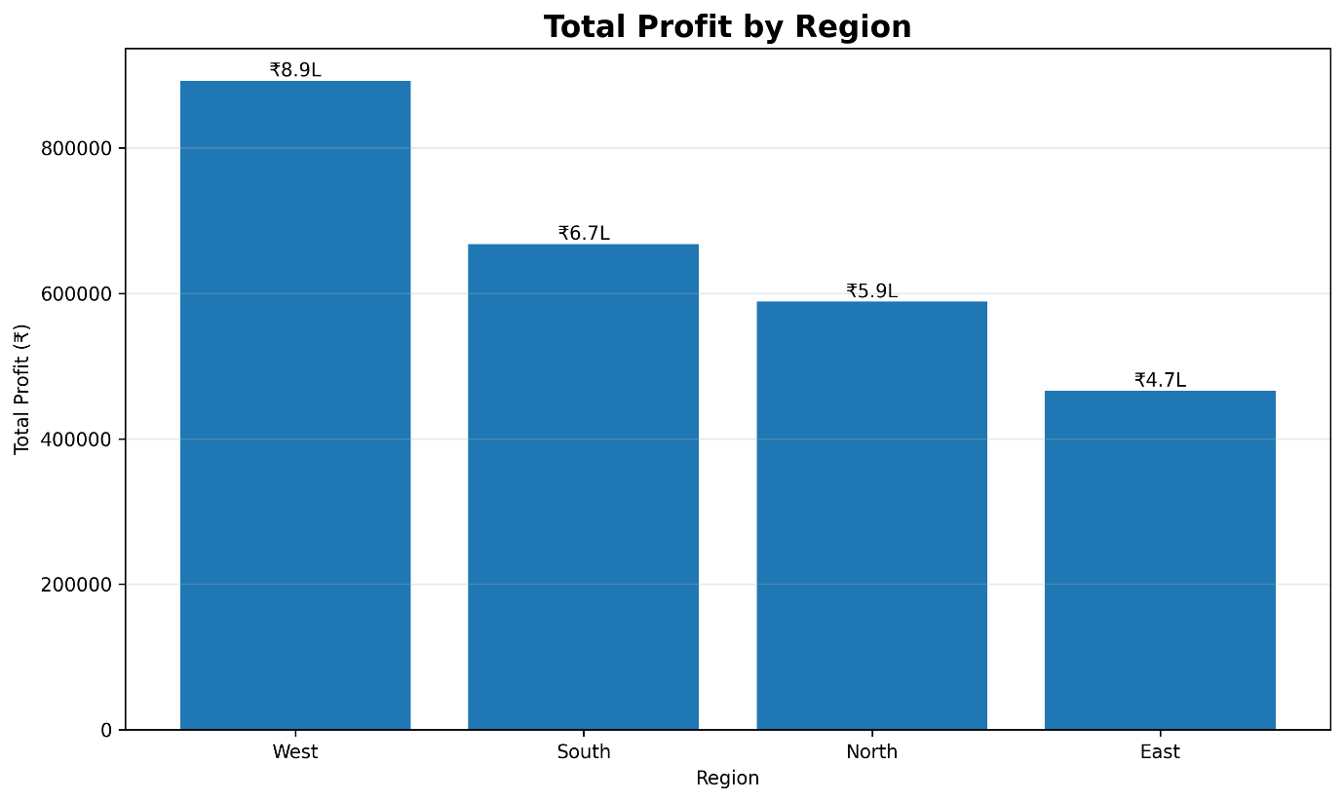
Figure 4: Profit by Region
Finding: West is the leading region in terms of both net revenue and profit. North requires attention because it has the highest regional return rate despite generating substantial revenue.
6.6 Sales Channel Analysis
The performance of Website, Mobile App, and Marketplace channels was compared using revenue, profit, margin, and return rate. The Website channel emerged as the strongest overall performer.
Sales Channel | Net Revenue | Profit | Profit Margin | Return Rate
Website | ₹41.04 L | ₹12.30 L | 29.98% | 6.72%
Mobile App | ₹30.42 L | ₹8.62 L | 28.35% | 7.18%
Marketplace | ₹20.70 L | ₹5.23 L | 25.29% | 7.72%
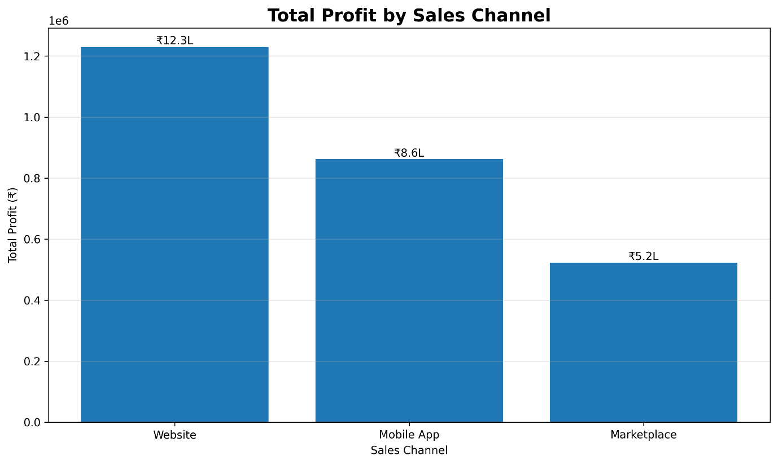
Figure 5: Profit by Sales Channel
Finding: The Website generates the highest revenue and profit and also has the highest profit margin. Marketplace performance is comparatively weaker due to its lower margin and higher return rate.
6.7 Return Analysis
Product returns were analyzed to understand their effect on revenue and profitability. Although returned orders represented a relatively small proportion of total orders, their financial impact was significant. The analysis compared returned and non-returned orders based on revenue and profit.
Returned vs Non-Returned Orders
Order Type | Orders | Net Revenue | Profit
Non-Returned | 2,301 | ₹90.47 L | ₹29.23 L
Returned | 176 | ₹1.67 L | −₹3.07 L
Total | 2,477 | ₹92.15 L | ₹26.16 L
Out of 2,477 orders, 176 orders were returned, resulting in an overall return rate of 7.11%. However, returned orders generated a negative profit of approximately ₹3.07 lakh, demonstrating that returns have a disproportionate impact on profitability compared with their share of total orders.
6.8 Impact of Returns on Profit
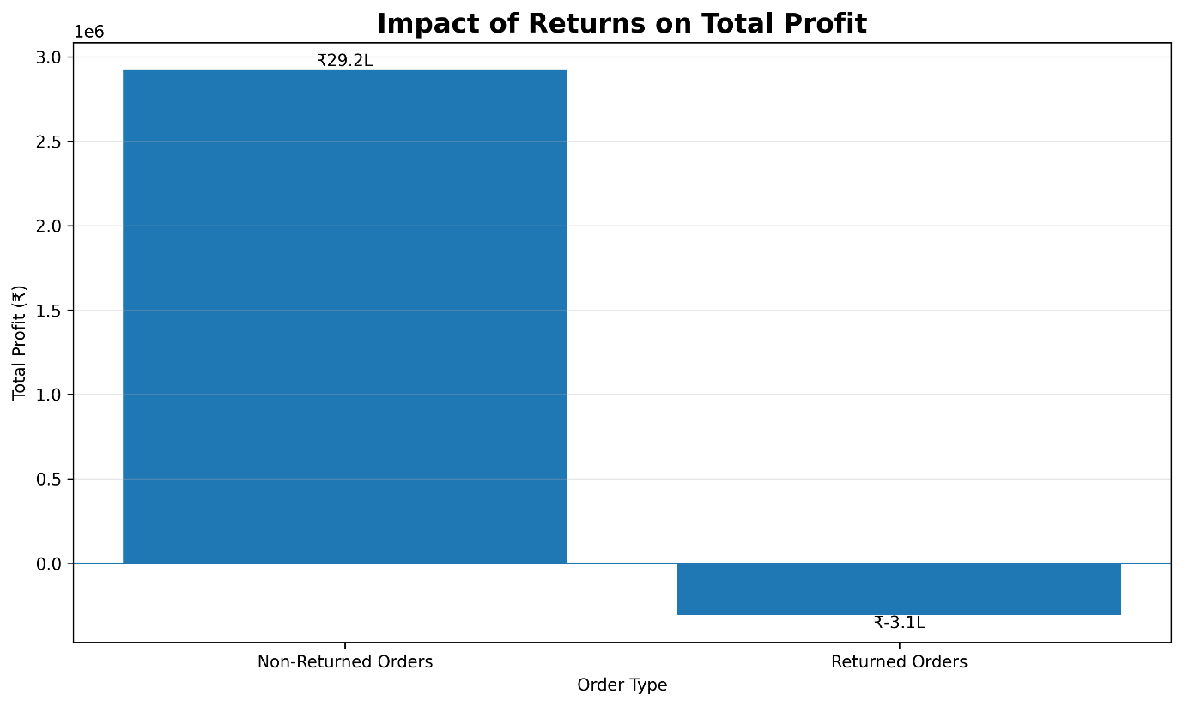
Figure 6: Impact of Returns on Profit
Finding: Returned orders are associated with substantial profit loss. This indicates that reducing return-related leakage can improve overall profitability even without increasing sales volume.
6.9 Category-wise Return Rate
Return rates were further analyzed across product categories to identify areas requiring operational attention.
Category | Return Rate
Home & Kitchen | 8.91%
Sports | 8.59%
Electronics | 8.50%
Accessories | 5.16%
Stationery | 4.25%
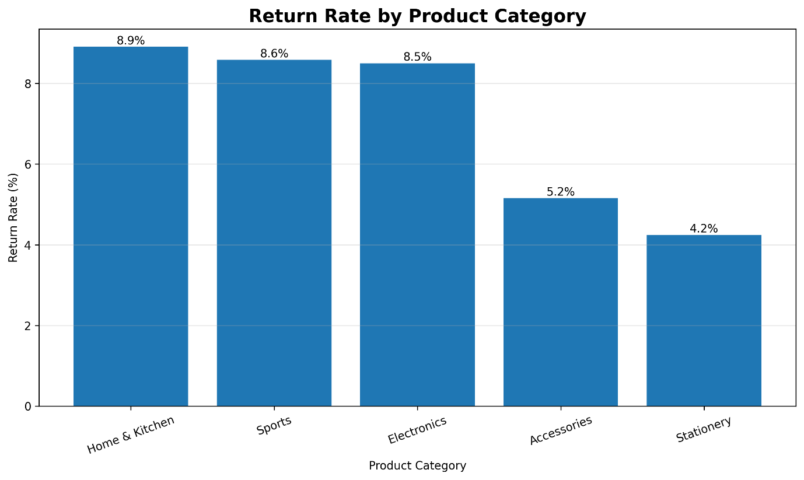
Figure 7: Return Rate by Product Category
Finding: Home & Kitchen has the highest return rate at 8.91%, followed by Sports and Electronics. Stationery has the lowest return rate at 4.25%.
6.10 Return-related Profit Leakage
Return-related financial impact was analyzed at the category level to identify where returned orders create the greatest profitability loss.
Category | Returned Orders | Return Amount | Profit Impact
Home & Kitchen | 44 | ₹1.72 L | −₹1.08 L
Electronics | 55 | ₹1.70 L | −₹1.00 L
Sports | 31 | ₹1.02 L | −₹0.53 L
Accessories | 26 | ₹0.58 L | −₹0.34 L
Stationery | 20 | ₹0.22 L | −₹0.12 L
Home & Kitchen has the highest return-related profit impact, with approximately ₹1.08 lakh in profit loss, followed by Electronics with approximately ₹1.00 lakh. This indicates that return reduction in these categories could provide a meaningful improvement in profitability.

6.11 Correlation Analysis
Correlation analysis was performed to understand the relationships between major numerical variables. The correlation matrix helps identify variables that move together and provides an additional statistical perspective on business performance.
Variable Pair | Correlation
Gross Sales – Cost of Goods | 1.00
Net Revenue – Gross Sales | 0.96
Net Revenue – Cost of Goods | 0.96
Gross Sales – Payment Fee | 0.94
Payment Fee – Cost of Goods | 0.94
Net Revenue – Payment Fee | 0.92
Net Revenue – Profit | 0.88
Gross Sales – Profit | 0.72
Cost of Goods – Profit | 0.70
Return Amount – Profit | −0.56
Strong positive correlations were observed between revenue-related variables and cost-related variables. Net Revenue and Profit also showed a strong positive relationship with a correlation of 0.88. In contrast, Return Amount showed a negative correlation of −0.56 with Profit, supporting the observation that higher return-related amounts are associated with lower profitability.
It should be noted that some high correlations, particularly among Gross Sales, Cost of Goods, Net Revenue, and Payment Fee, are partly expected because these variables are mathematically related to transaction value. Therefore, correlation should not be interpreted as proof of causation.
6.12 Outlier Analysis
Outlier analysis was performed using the Interquartile Range (IQR) method to identify unusually high or low observations in important financial variables.
Table:
Variable | Outliers Identified | Percentage
Gross Sales | 166 | 6.70%
Net Revenue | 176 | 7.11%
Profit | 247 | 9.97%
Return Amount | 176 | 7.11%

The identified outliers were investigated rather than automatically removed. High-value sales and profit observations may represent legitimate business transactions and therefore were retained. The Return Amount variable also contains many zero values for non-returned orders, which makes IQR-based detection less informative and causes returned transactions to appear as outliers. These observations represent actual business behavior rather than data-entry errors.
6.13 EDA Summary
The exploratory analysis revealed several important characteristics of the e-commerce business. West was the strongest region in terms of revenue and profit, while Electronics and Home & Kitchen were the leading revenue-generating categories. The Website channel demonstrated the strongest overall profitability. At the same time, product returns emerged as a significant source of profitability leakage. Although only 7.11% of orders were returned, returned transactions generated approximately ₹3.07 lakh in negative profit. Home & Kitchen showed the highest return rate and the largest category-level return-related profit impact.
These findings provided the foundation for the subsequent visualization and Power BI dashboard analysis.

7. Data Visualization
Data visualization was used to communicate important patterns and business performance identified during exploratory data analysis. The visualizations were created using Python libraries including Matplotlib and Seaborn. Each visualization was selected based on the type of business question being analyzed, such as revenue trends, category performance, regional profitability, channel performance, and return-related losses.
7.1 Net Revenue by Year
The Net Revenue by Year visualization presents the variation in net revenue across different years in the dataset. It provides a high-level view of revenue performance over time and helps identify changes in overall business revenue.
Finding: The visualization provides an overview of how net revenue varies across the available years and helps identify stronger and weaker periods of business performance.
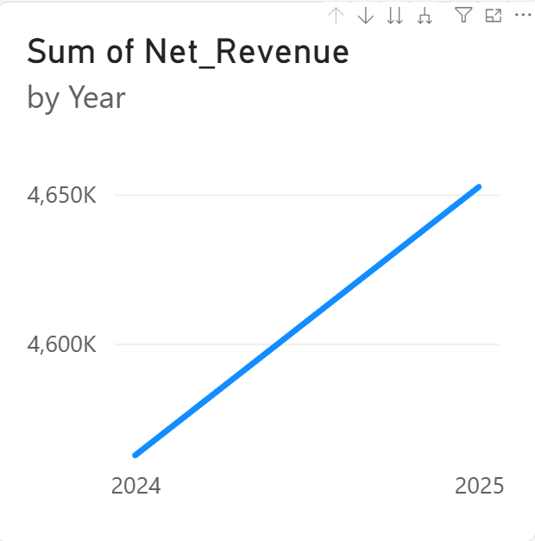
7.2 Net Revenue by Product Category
The Net Revenue by Product Category visualization compares revenue generated by the five product categories: Electronics, Home & Kitchen, Accessories, Sports, and Stationery.
Finding: Electronics generated the highest net revenue, followed closely by Home & Kitchen, while Stationery contributed the lowest net revenue.
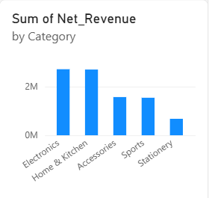
7.3 Total Profit by Region
The Total Profit by Region visualization compares profitability across the four geographical regions: West, South, North, and East.
Finding: The West region generated the highest total profit, making it the strongest regional contributor to overall profitability.
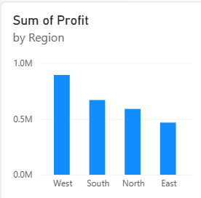
7.4 Total Profit by Sales Channel
The Total Profit by Sales Channel visualization compares profitability across the Website, Mobile App, and Marketplace channels.
Finding: The Website channel generated the highest total profit, while Marketplace generated the lowest profit among the three channels.
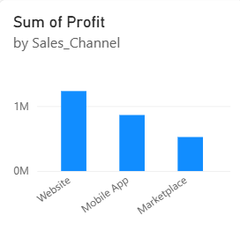
7.5 Impact of Returns on Total Profit
The Impact of Returns on Total Profit visualization compares profit between returned and non-returned orders.
Finding: Returned orders resulted in a significant negative profit impact of approximately ₹3.07 lakh, highlighting product returns as an important source of profitability leakage.
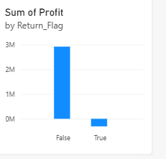
7.6 Return Rate by Product Category
The Return Rate by Product Category visualization compares the percentage of returned orders across product categories.
Finding: Home & Kitchen recorded the highest return rate at 8.91%, while Stationery recorded the lowest return rate at 4.25%.
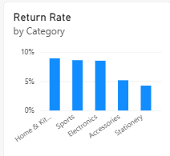
7.7 Profit Margin by Sales Channel
The Profit Margin by Sales Channel visualization compares the profitability efficiency of the three sales channels.
Finding: Website recorded the highest profit margin at 29.98%, while Marketplace recorded the lowest at 25.29%.
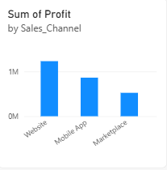
7.8 Visualization Summary
The visualizations provide multiple perspectives on e-commerce business performance. Revenue trends help monitor performance over time, while category and regional comparisons identify high-performing business segments. Channel-level analysis highlights differences in profitability and margin, while return-related visualizations reveal the impact of product returns on profitability. Together, these visualizations convert the analytical results into an easily interpretable business view.

8. Power BI Dashboard
8.1 Dashboard Overview
The Power BI dashboard was developed to provide an interactive business intelligence view of the e-commerce sales data. The dashboard consolidates key performance indicators, revenue and profitability analysis, return-related performance, and interactive filters into a single view.
The dashboard is designed to help business users quickly understand overall financial performance, identify high-performing categories, regions and sales channels, and identify areas where product returns are affecting profitability.
The dashboard title, “E-Commerce Revenue & Profitability Intelligence Dashboard”, reflects the primary objective of the analysis: understanding the relationship between revenue, profit, returns, and profitability leakage.
8.2 Key Performance Indicators (KPIs)
Three key performance indicators were included in the dashboard to provide an immediate summary of business performance.
KPI | Value | Business Meaning
Net Revenue | ₹9,214,991.26 | Revenue retained after discounts and returns
Total Profit | ₹2,615,976.06 | Overall profit generated from the orders
Return Rate | 7.11% | Percentage of orders that were returned
These KPIs provide a quick executive-level summary of the business. Net Revenue measures the revenue retained after adjustments, Total Profit indicates overall profitability, and Return Rate highlights the scale of product returns.
8.3 Dashboard Visualizations
The dashboard contains multiple visualizations that provide different perspectives of business performance. The visualizations included in the dashboard are:
- Net Revenue by Year – shows the change in revenue across different years.
- Net Revenue by Product Category – compares revenue contribution across product categories.
- Total Profit by Region – identifies the regions generating the highest profit.
- Total Profit by Sales Channel – compares profitability across Website, Mobile App, and Marketplace channels.
- Impact of Returns on Total Profit – highlights the difference in profitability between returned and non-returned orders.
- Return Rate by Product Category – compares return rates across product categories.
- Profit Margin by Sales Channel – evaluates the profitability efficiency of different sales channels.
These visualizations complement the KPI cards by allowing users to investigate the factors contributing to overall revenue, profitability, and return performance.
8.4 Interactive Filters / Slicers
To make the dashboard interactive, three slicers were incorporated:
- Region – allows users to filter the dashboard based on geographical region.
- Sales Channel – allows comparison between Website, Mobile App, and Marketplace performance.
- Category – allows users to focus on the performance of a particular product category.
The slicers dynamically filter the dashboard visuals, enabling users to explore specific business segments without modifying the underlying dataset.
8.5 Dashboard Design and Business Purpose
The dashboard follows a structured layout in which the most important KPIs are positioned prominently at the top, followed by revenue, profitability, regional, channel, and return-related visualizations.
The dashboard was designed to provide a clear and easily interpretable view of business performance rather than presenting raw analytical results. Interactive slicers allow users to drill into specific regions, sales channels, and product categories.
From a business perspective, the dashboard helps decision-makers monitor revenue and profit, identify high-performing business segments, evaluate return-related profitability issues, and compare the performance of different sales channels.
8.6 Power BI Dashboard
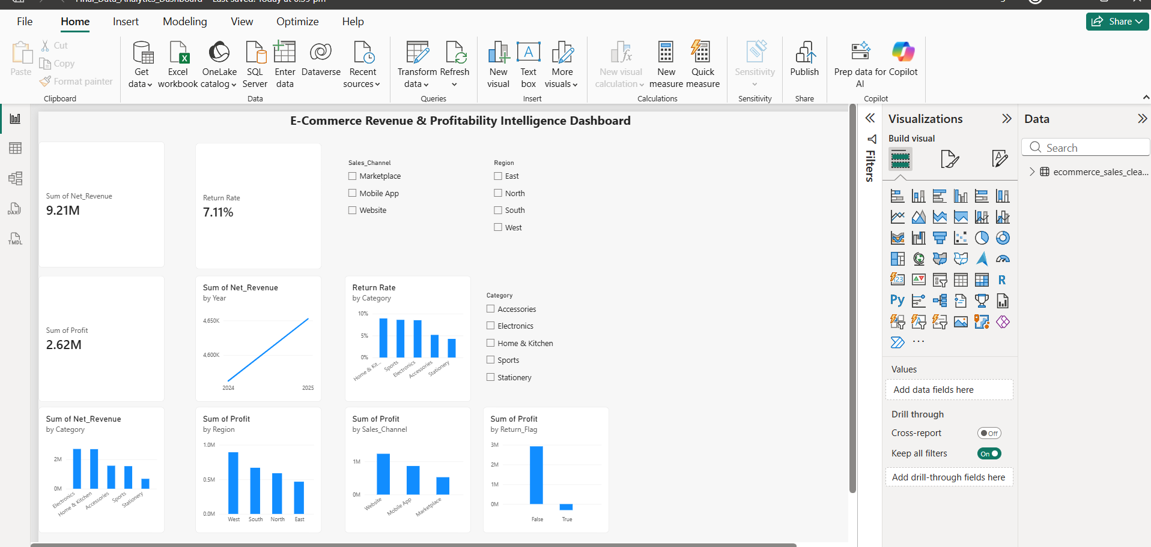
Figure 15: E-Commerce Revenue & Profitability Intelligence Power BI Dashboard
Figure 15 presents the final interactive Power BI dashboard developed for the project. The dashboard combines the three major KPIs, multiple business visualizations, and interactive slicers into a single analytical interface. It provides a consolidated view of revenue, profitability, sales channels, regional performance, and return-related leakage.
8.7 Power BI Dashboard Summary
The Power BI dashboard successfully fulfills the business intelligence requirements of the project. It includes three KPI cards, seven analytical visualizations, and three interactive slicers. The dashboard enables users to monitor key business metrics and explore performance across different regions, product categories, and sales channels.
The dashboard also supports the identification of important business issues, particularly the negative profitability impact associated with returned orders. Therefore, it acts as an interactive decision-support tool for understanding revenue performance and profitability leakage.
9. Business Insights and Recommendations
9.1 Key Business Insights
The analysis of the cleaned e-commerce dataset and the Power BI dashboard revealed several important business insights related to revenue, profitability, regional performance, sales channels, and product returns.
Insight 1: West Region is the Strongest Performing Region
The West region generated the highest net revenue of ₹31,57,801.35 and the highest total profit of ₹8,92,462.00 among all regions. This indicates that the West region is currently the strongest contributor to overall business performance.
The North region, although generating substantial revenue, recorded the highest return rate of 8.01%. This indicates that there is an opportunity to investigate customer returns and improve operational performance in the North region.
Insight 2: Electronics is the Leading Product Category
Electronics generated the highest net revenue of ₹27,16,934.78 and the highest total profit of ₹7,27,283.25 among the five product categories.
This indicates that Electronics is a major revenue and profit driver for the business. However, it also recorded a return rate of 8.50%, which suggests that its strong financial contribution is accompanied by a significant return-related risk.
Insight 3: Product Returns Create Significant Profit Leakage
Only 176 out of 2,477 orders were returned, resulting in an overall return rate of 7.11%. However, the financial impact of these returns is considerably larger than the order percentage suggests.
Returned orders generated a total profit of approximately −₹3,06,683.47, compared with ₹29,22,659.53 profit from non-returned orders.
This shows that product returns are not simply an operational issue; they have a direct negative impact on profitability and represent a significant source of profit leakage.
Insight 4: Home & Kitchen Has the Highest Return Risk
The Home & Kitchen category recorded the highest return rate of 8.91%. It also had the largest return-related profit impact, with approximately ₹1,07,796.37 in profit loss associated with returned orders.
The average loss per returned order in this category was approximately ₹2,449.92, making Home & Kitchen the most important category for return-leakage investigation.
Insight 5: Website is the Strongest Sales Channel
The Website sales channel generated the highest net revenue of ₹41,03,741.21 and the highest total profit of ₹12,30,386.77.
It also recorded a profit margin of approximately 29.98%, which was higher than the Mobile App (28.35%) and Marketplace (25.29%) channels.
Therefore, the Website currently represents the strongest sales channel in terms of revenue, absolute profit, and profitability efficiency.
Insight 6: Marketplace Requires Attention
The Marketplace channel recorded the lowest profit margin at approximately 25.29% and the highest return rate among the three channels at 7.72%.
Although the Marketplace contributes meaningful revenue, its combination of lower profitability and higher returns suggests that its pricing, fees, customer experience, product quality, and return patterns should be investigated.
Insight 7: Stationery Has Lower Scale but High Profitability Efficiency
The Stationery category generated the lowest total net revenue of ₹6,78,141.37 and total profit of ₹2,58,303.50. However, it achieved the highest profit margin of approximately 38.09% and the lowest return rate of 4.25%.
This indicates that lower sales volume does not necessarily mean poor business performance. Stationery demonstrates strong profitability efficiency and relatively low return risk.

9.2 Data-Driven Recommendations
Recommendation 1: Reduce Return-Related Profit Leakage
The business should prioritize reducing returns in Home & Kitchen and Electronics, as these categories contribute the largest return-related profit losses.
The company should analyse return reasons and investigate factors such as product quality, packaging, product descriptions, delivery handling, and fulfilment issues. Reducing unnecessary returns can directly improve profitability without requiring an equivalent increase in sales.
Recommendation 2: Optimize Sales Channel Performance
The company should continue strengthening the Website channel, which currently generates the highest revenue and profit with the strongest profit margin.
At the same time, the Marketplace channel should be reviewed to identify the reasons behind its lower margin and higher return rate. Pricing, marketplace fees, product listings, customer experience, and return policies should be evaluated to improve its profitability.
Recommendation 3: Investigate Regional Return Patterns
The North region has the highest return rate at 8.01%. The business should investigate whether specific products, customers, fulfilment processes, or delivery conditions are contributing to this higher return rate.
The West region, being the strongest-performing region, can be used as a benchmark to identify successful operational and sales practices that may be applied to other regions.

9.3 Overall Business Interpretation
Overall, the analysis shows that increasing sales alone is not sufficient to maximize business profitability. The business must simultaneously manage revenue generation, profit margins, sales-channel efficiency, and return-related losses.
The analysis particularly highlights the importance of controlling product returns. Although returned orders account for only 7.11% of total orders, their associated negative profit impact is substantial. Therefore, reducing return leakage while strengthening high-performing categories, regions, and sales channels can provide a practical path toward improving overall profitability.

10. Conclusion
This project successfully demonstrated an end-to-end data analytics workflow for an e-commerce business dataset. The analysis covered dataset generation, data inspection, data cleaning, exploratory data analysis, statistical analysis, visualization, business intelligence, and business recommendation generation.
The raw dataset initially contained duplicate records, missing values, invalid numerical values, and future-dated records. These issues were identified and systematically addressed during the data preparation stage. After cleaning, the final dataset contained 2,477 valid records with no remaining missing values or duplicate records.
Exploratory Data Analysis identified important patterns in revenue, profit, product categories, regions, sales channels, and customer returns. The analysis showed that the West region, Electronics category, and Website sales channel were major contributors to business performance. At the same time, product returns emerged as a major source of profitability leakage, particularly in the Home & Kitchen category.
A Power BI dashboard was developed to convert these analytical results into an interactive business intelligence solution. The dashboard includes key performance indicators, multiple analytical visualizations, and interactive slicers for Region, Sales Channel, and Category.
Overall, the project demonstrates how data analytics can transform raw business data into actionable insights. The findings can support management in improving profitability, reducing return-related losses, optimizing sales channels, and making more informed business decisions.

11. Git and GitHub Workflow
11.1 Git and GitHub Implementation
Git and GitHub were used to maintain version control and store the project repository. Git was installed and configured locally, and the project was connected to a GitHub repository.
GitHub Repository:
Week 6 Final Data Analytics Project
Repository:
https://github.com/AasthaMehtaa/Week6-Final-Data-Analytics-Project
11.2 Git Workflow Followed
The following Git workflow was followed during project development:
- Git was installed and configured on the local system.
- A GitHub repository was created for the project.
- The repository was cloned to the local system.
- Project folders and initial files were added.
- Changes were staged using git add.
- Changes were saved using meaningful commits with git commit.
- Local changes were uploaded to GitHub using git push.
- Repository changes were retrieved using git pull.
- The final project files were maintained under version control.

11.3 Meaningful Commits
Commit | Purpose
119fdf3 | chore: initialize final data analytics project
9903bf0 | docs: expand project documentation
21335ce | feat: complete data preparation EDA and visualizations
These commits demonstrate the use of version control throughout different stages of project development rather than uploading the complete project only once.
11.4 Git Commands Used
The major Git commands used during the project included:
git clone
git status
git add
git commit
git push
git pull
The use of Git and GitHub provided version tracking, backup, and a publicly accessible project repository for documentation and portfolio purposes.
12. Project Structure
The project was organized into separate folders according to the purpose of each file and project stage.
Week6_Final_Data_Analytics_Project/
│
├── data/
│ ├── raw/
│ │ ├── ecommerce_sales_raw.csv
│ │ └── data_dictionary.csv
│ │
│ └── cleaned/
│ └── ecommerce_sales_cleaned.csv
│
├── notebooks/
│ └── Final_Data_Analytics_Project.ipynb
│
├── src/
│ └── generate_dataset.py
│
├── visualizations/
│ ├── visualization_01_monthly_revenue.png
│ ├── visualization_02_revenue_by_category.png
│ ├── visualization_03_profit_by_region.png
│ ├── visualization_04_profit_by_sales_channel.png
│ ├── visualization_05_return_impact_on_profit.png
│ ├── visualization_06_return_rate_by_category.png
│ └── visualization_07_profit_margin_by_sales_channel.png
│
├── powerbi/
│ └── Final_Data_Analytics_Dashboard.pbix
│
├── report/
│ └── Final_Data_Analytics_Project_Report.pdf
│
├── presentation/
│ └── Final_Data_Analytics_Project_Presentation.pptx
│
├── .gitignore
└── README.md
Folder Description
- data/raw/ – Contains the original generated dataset and data dictionary.
- data/cleaned/ – Contains the cleaned dataset used for analysis and Power BI.
- notebooks/ – Contains the Jupyter Notebook containing the complete analysis workflow.
- src/ – Contains Python source code used for dataset generation.
- visualizations/ – Contains the analytical charts generated during the project.
- powerbi/ – Contains the final Power BI dashboard file.
- report/ – Contains the final project report.
- presentation/ – Contains the project presentation.
- README.md – Provides project documentation and an overview of the complete workflow.
- .gitignore – Prevents unnecessary files such as the Python virtual environment and cache files from being committed.
This modular structure keeps the project organized and makes it easier to understand, reproduce, and maintain.
13. References
The following official documentation and software resources were referred to during the development of the project:
- Python Documentation – Python programming language reference and documentation.
- Pandas Documentation – Used for data loading, cleaning, transformation, aggregation, and analysis.
- NumPy Documentation – Used for numerical operations and dataset generation.
- Matplotlib Documentation – Used for data visualization.
- Seaborn Documentation – Used for statistical data visualization.
- Jupyter Notebook Documentation – Used for interactive data analysis and documentation.
- Microsoft Power BI Documentation – Used for dashboard development, visualizations, KPIs, and slicers.
- Git Documentation – Used for version control and Git workflow.
- GitHub Documentation – Used for repository management and project hosting.
Dataset Note
The dataset used in this project is a realistic synthetic e-commerce sales dataset generated using Python for educational and analytical purposes. It was intentionally designed to contain realistic business attributes and controlled data-quality issues so that the complete data preparation, EDA, visualization, and business intelligence workflow could be demonstrated.

